**Loan Performance and Investor Return Analysis**

**Introduction**

In the rapidly evolving financial landscape, understanding the dynamics of loan performance and investor returns is critical for both lenders and borrowers. The peer-to-peer (P2P) lending market offers unique opportunities, allowing individuals to directly invest in loans, bypassing traditional financial institutions. This decentralized approach provides access to a wider borrower base and the potential for higher returns. However, it also presents challenges in managing loan performance due to diverse borrower profiles and varying risk factors.

This analysis is focused on evaluating loan performance and understanding investor returns within the Prosper lending portfolio. By examining metrics such as loan status, borrower credit scores, interest rates, and repayment history, this report seeks to identify trends that influence returns. A detailed analysis helps to uncover factors leading to loan defaults, late payments, and successful repayments, ultimately guiding investment decisions to maximize returns while minimizing risks.

**Objective**

The primary goal of this analysis is to provide a comprehensive evaluation of loan performance and investor returns. Specifically, it aims to:

1. **Assess Loan Performance**: Analyze the current, delinquent, and defaulted loan statuses to understand the factors influencing successful loan repayment and potential defaults.
2. **Evaluate Investor Returns**: Investigate the relationship between borrower characteristics (e.g., credit score, debt-to-income ratio) and investor yields to identify opportunities for optimizing returns.
3. **Monitor Risk Factors**: Track and measure delinquency and default rates, highlighting the impact of various borrower attributes on loan outcomes.
4. **Optimize Investment Strategies**: Provide insights into average interest rates, loan amounts, and borrower credit grades to inform smarter lending practices, leading to more favorable returns for investors.
5. **Support Data-Driven Decision-Making**: Enable stakeholders to make informed investment decisions by visualizing trends in loan performance, default risk, and investor returns, thereby enhancing portfolio management.

This analysis will serve as a crucial tool for understanding how borrower behavior impacts loan outcomes and guides strategic lending decisions, ensuring robust portfolio performance and optimized investor return

**About the Dataset :**

The dataset contains 113,937 rows and 81 columns, representing a comprehensive loan portfolio from Prosper. Here's a summary of key fields:

1. **ListingKey**: Unique key for each loan listing.
2. **LoanStatus**: Includes statuses such as "Completed," "Current," "Defaulted," and more.
3. **BorrowerAPR**: The borrower's Annual Percentage Rate (APR) ranges from 0% to a high of around 29%.
4. **LoanOriginalAmount**: Varies significantly, with a minimum of $1,000 and a maximum of $25,000.
5. **Term**: Most loans have terms of 36 months.
6. **PercentFunded**: Indicates how much of the loan was funded, with a mean value near 100%.
7. **Investors**: The number of investors ranges from 1 to a maximum of 1,189 per loan.

**Data Preprocessing:**

For the data preprocessing task, we performed data cleaning, and data encoding, The processes for data cleaning and encoding are outlined below as follows:

**Data Cleaning:**

The data cleaning was done to ensure the accuracy of the data analysis. Various steps were taken to clean the data. The steps along with their detailed explanation are given below:

**Date Transformation:**

At first, the five key date-related columns—**DateCreditPulled**, **FirstRecordedCreditLine**, **ListingCreationDate**, **LoanOriginationDate,** and **ClosedDate**—were converted to a standardized datetime format. This ensures consistent handling of date information across the dataset, allowing for accurate time-based analysis, such as tracking loan origination trends or evaluating the timing of loan closures. Any invalid date entries are handled using the **errors='coerce'** parameter, converting them to **NaT** (Not a Time) for better data integrity.

**Working with Null Values:**

After checking for null values, the following columns were returned:

Columns with more than 80% null values were dropped, while key columns exceeding the 80% threshold were retained for further cleaning and analysis.

Since the **CreditGrade** and **ProsperRating** columns were categorical, their null values were imputed using the mode.

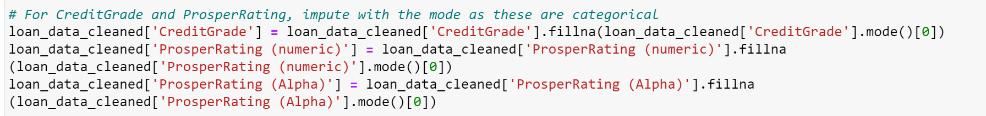

The null values of **EstimatedReturn** and **ProsperScore** columns were imputed with their median.



The remaining **null values** were imputed with their median.

The null values of the remaining **categorical columns** were imputed with their mode. A **for loop** was used to impute those values.

**Summary:**

1. **Drop Columns with > 80% Null Values**:
   * The drop_threshold is set to 80%. Columns with more than 80% missing values are identified and filtered.
   * **Important Columns** (CreditGrade, ProsperScore, EstimatedReturn, ProsperRating) are excluded from being dropped.
   * Unimportant columns with more than 80% missing values are dropped from the dataset.
2. **Imputation for Important Columns**:
   * **Mode Imputation** (for categorical data): Missing values in CreditGrade, ProsperRating (numeric), and ProsperRating (Alpha) are imputed using the most frequent value (mode).
   * **Median Imputation** (for numerical data): EstimatedReturn and ProsperScore are imputed using the median values.
3. **Imputation for Other Numerical Columns**:
   * For a list of other important numerical columns (e.g., BorrowerAPR, CreditScoreRangeLower, RevolvingCreditBalance), missing values are filled with the **median**.
4. **Imputation for Categorical Columns**:
   * Columns like BorrowerState, Occupation, and EmploymentStatus are imputed with their **mode** values.
5. **Check for Remaining Null Values**:
   * The number and percentage of missing values remaining in the dataset are recalculated to ensure no important missing data remains.

**Checking for Duplicate Values:**

After checking for duplicate values, no duplicate rows were found.

**Outlier Detection:**

48 numerical columns in the dataset were identified to contain outliers. These outliers were detected using the Interquartile Range (IQR) method. The code used for identifying these outliers is provided below:

The columns with outliers are listed below:

The following columns were visualized using boxplots to gain a deeper understanding of the distribution and identify any potential outliers. Through this visualization, it became evident that many of these columns exhibited patterns consistent with the dataset's overall structure. However, several columns displayed unexpected values, particularly negative and extremely high figures, which were considered abnormal based on typical financial data expectations.

To address these anomalies, domain knowledge was applied to determine the plausible range for each of these columns. By referencing industry standards and Prosper-specific lending criteria, we identified what would be considered "normal" values for variables such as borrower APR, loan amounts, and credit-related fields.

Using these insights, we filtered out the data points that fell outside of these expected ranges to ensure that the dataset remained accurate and relevant for further analysis. The following code illustrates the approach used to filter the columns based on these findings, allowing for a more accurate representation of the dataset without skewed values caused by outliers.

This step was critical in ensuring the integrity of the data for subsequent analyses and modeling efforts. The code for filtering the columns with unrealistic values are given below:

Then, the dataset was adjusted to handle unrealistic values by setting limits on loan amounts and monthly income, ensuring they fall within reasonable ranges. Loan amounts were capped at 10 million, and monthly incomes were capped at 1 million to avoid extreme outliers. Additionally, credit score ranges were refined, with a lower bound of 300 and an upper limit of 850, aligning with common credit scoring standards. This ensures more accurate and reliable data for analysis.

**Summary:**

1. **Outlier Detection**: The function detect_outliers uses the Interquartile Range (IQR) method to detect outliers for specified numerical columns. It calculates the lower and upper bounds and identifies values that fall outside these bounds as outliers.
2. **Visualization**: The function visualize_outliers_in_rows creates boxplots for the numerical columns, displaying three plots per row to visualize outliers.
3. **Data Cleaning for Unrealistic Values**: The code filters rows with potential data errors, such as negative loan amounts, negative income, unrealistic credit scores (below 300 or above 850), and very high loan amounts or incomes.
4. **Imputation**: Unrealistic values are imputed with reasonable defaults:
   * Loan amounts are capped at 10M.
   * Monthly income is capped at 1M.
   * Credit scores are clipped between 300 and 850.
5. **Numerical Columns Identification**: It identifies all numerical columns in the dataset to apply the outlier detection function, and filters columns with outliers for further review.

**Data Encoding:**

We focused on the **LoanStatus** column for encoding. Initially, we examined the categorical values within the column and their respective distributions in the dataset to understand the different loan statuses.

Following this, the **LoanStatus** column was encoded by utilizing the information from the **ClosedDate** and **LoanCurrentDaysDelinquent** columns.

The process involved creating binary columns to capture loan statuses based on specific conditions:

* The **ClosedDate** column was used to classify loans as either open or closed (binary: 1 for closed, 0 for open).
* The **LoanCurrentDaysDelinquent** column helped identify loans that were delinquent for more than 180 days, encoding them as binary values (1 for delinquent, 0 otherwise).

This transformation allowed us to convert the loan status data into a more analyzable binary format, making it easier to track loan performance and delinquency across the portfolio.

**Creating the ‘Default Rate’ Column:**

To enhance the analysis, a **Default Rate** column was added to track the proportion of loans that have defaulted. This helps assess the overall risk and health of the loan portfolio.



Please refer to the [Colab notebook](https://colab.research.google.com/drive/1FIVEDtFVvBNoEpkQJkEnVNqw3wgjyPKV#scrollTo=6e3c947e) for a comprehensive understanding of the data transformations, cleaning, and encoding processes. The key elements related to the dashboard are included in the report, while the [Colab file](https://colab.research.google.com/drive/1FIVEDtFVvBNoEpkQJkEnVNqw3wgjyPKV#scrollTo=6e3c947e) provides additional details, including more extensive data cleaning and transformations for better insights. The dashboard, along with detailed explanations of its visualizations, is presented below. Each visualization has been carefully designed to provide insights into key borrower risk factors and loan performance metrics. The dashboard offers an interactive and dynamic view, enabling stakeholders to analyze data in real time and make informed decisions. This comprehensive approach ensures that all relevant aspects of borrower risk are effectively visualized and accessible for strategic decision-making.

**Dashboard Overview:**

After completing the measures, the focus shifted to building the dashboard. To guide the dashboard creation process, several problem statements were formulated.

These **problem statements** are as follows:

1. What factors contribute to the distribution of loans among different statuses, and how can the proportion of defaulted and late loans be reduced?
2. How does the lender yield correlate with estimated losses, and what patterns can help minimize risks while maintaining favorable yields?
3. What trends are evident in loan status changes over the years, and how do economic factors or market conditions influence these trends?
4. How does the credit grade of borrowers impact investor returns, and which grades offer the best risk-reward balance?
5. What borrower characteristics influence delinquency rates for different Prosper ratings, and how can these insights guide better lending decisions?
6. How have average lender yields fluctuated over time, and what factors contribute to significant changes in yield trends?
7. How can the overall default rate be reduced while maintaining or increasing average lender yield, total loan status, and investor return by loan term?These statements aim to guide a thorough exploration of key borrower risk factors and performance indicators.

These problem statements focus on understanding loan performance, managing risks, and enhancing returns within the P2P lending context.

**Observation:**

**1. What factors contribute to the distribution of loans among different statuses, and how can the proportion of defaulted and late loans be reduced?**

**Insights:**

* Current loans make up the largest portion of the dataset (49.66%), indicating a healthy proportion of active loans.
* Defaulted and Late loans combined account for a significant portion, emphasizing the need for better risk assessment.
* Strategies targeting the reduction of late payments can potentially decrease the overall default rate.

**2. How does the lender yield correlate with estimated losses, and what patterns can help minimize risks while maintaining favorable yields?**

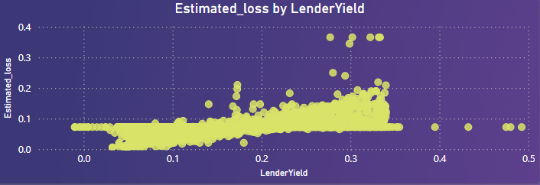

**Insights:**

* Higher lender yields tend to correlate with higher estimated losses, indicating a trade-off between risk and return.
* There are noticeable clusters where lender yield remains high, but estimated losses are lower, suggesting potential for optimizing loan criteria.
* Investors can use this pattern to find a balance between acceptable risk levels and expected returns.

**3. What trends are evident in loan status changes over the years, and how do economic factors or market conditions influence these trends?**

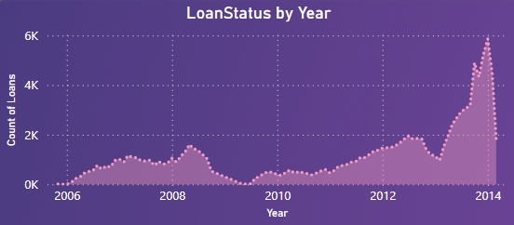

**Insights**:

* A significant increase in loan counts occurred post-2010, indicating rapid growth in the P2P lending market.
* Economic or market conditions may have driven fluctuations, especially noticeable around economic downturns or recovery periods.
* The rise in loan counts suggests an increased borrower base, requiring stricter risk assessments.

**4. How does the credit grade of borrowers impact investor returns, and which grades offer the best risk-reward balance?**

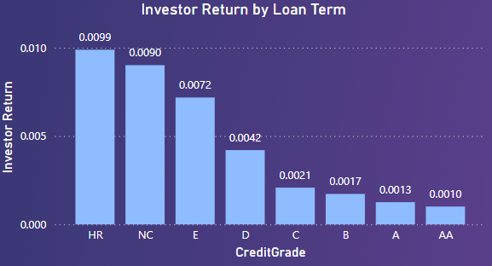

**Insights**:

* Lower credit grades like HR (High Risk) and NC yield the highest investor returns, indicating higher risk-taking rewards.
* Higher credit grades (e.g., AA) result in lower returns, suggesting safer but less profitable investments.
* Investors need to assess their risk tolerance when choosing credit grades to optimize returns.

**5. What borrower characteristics influence delinquency rates for different Prosper ratings, and how can these insights guide better lending decisions?**

**Insights**:

* Prosper Rating 4 has the highest delinquency rate, indicating that mid-level ratings may pose higher risks.
* Lower Prosper Ratings (e.g., 2) show relatively lower delinquency rates, suggesting safer lending options.
* Focusing on borrower attributes in higher-risk Prosper Ratings can aid in crafting better lending criteria.

**6. How have average lender yields fluctuated over time, and what factors contribute to significant changes in yield trends?**

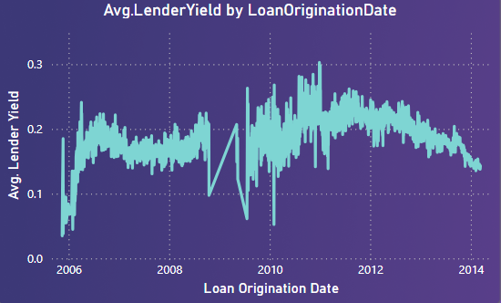

**Insights:**

* The lender yield showed significant fluctuations before 2010, indicating possible shifts in lending strategies or economic impacts.
* After 2010, yields stabilized, suggesting improved consistency in loan performance and risk assessment.
* Major peaks and dips highlight periods where market conditions significantly affected returns.

**7. How can the overall default rate be reduced while maintaining or increasing average lender yield, total loan status, and investor return by loan term?**



**Insights**:

* **Average Lender Yield**: The average yield stands at 0.18, indicating a balanced return for investors across all loan statuses.
* **Overall Default Rate**: The default rate is 4.40%, highlighting room for improvement in risk mitigation.
* **Total Loan Status**: With 113.94K loans, the portfolio is extensive, requiring comprehensive monitoring and adjustments.
* **Estimated Loss**: A low estimated loss of 0.08 indicates that, despite risks, overall losses remain controlled.
* **Investor Return by Loan Term**: At 0.0022, investor returns vary by loan term, emphasizing the need for term-specific strategies.

These insights aim to provide a clear understanding of loan performance, risk factors, and investor returns to guide strategic decision-making.

**Conclusion**

The comprehensive analysis of the Prosper loan portfolio offers valuable insights into borrower risk, loan performance, and investor returns in the peer-to-peer (P2P) lending market. The study highlights the strengths and weaknesses of the current loan portfolio and identifies patterns that can help lenders make informed decisions. Key takeaways from the analysis include the significance of understanding borrower profiles, credit grades, and market trends to ensure a healthy portfolio and optimize investor returns.

The dataset indicates that while the P2P model opens doors to higher returns, it also brings exposure to diverse risks, especially in mid-risk categories. There is a clear trade-off between risk and reward—high-risk credit grades offer substantial returns but carry increased chances of defaults. The analysis reveals that economic conditions, borrower characteristics, and loan-specific attributes significantly impact loan outcomes and investor profitability. Yield trends and loan status evolution over time highlight the importance of adapting strategies based on market conditions and data-driven insights.

By closely monitoring delinquency and default trends, optimizing credit assessments, and tailoring investment strategies, Prosper can improve loan performance, reduce default rates, and enhance investor confidence.

**Recommendations**

Based on the findings, the following strategic recommendations can help Prosper optimize its loan portfolio and achieve sustainable growth:

1. **Strengthen Borrower Risk Assessment**:

* Introduce more sophisticated credit assessment models that factor in additional borrower characteristics such as employment stability, past credit behavior, and detailed debt-to-income ratios.
* Implement advanced machine learning algorithms for predictive analytics to assess the probability of defaults and tailor lending criteria accordingly.
* Increase monitoring efforts on mid-level Prosper Ratings, which show higher delinquency rates, to reduce future risks.

1. **Implement a Tiered Interest Rate Strategy**:

* Adjust interest rates dynamically based on borrower profiles, Prosper Ratings, and market trends to better reflect the associated risk. Offering competitive rates to lower-risk borrowers can attract a safer borrower pool.
* Consider offering tiered investment options for investors, where they can select risk preferences based on credit grades, loan terms, and yield expectations, balancing the portfolio risk-reward ratio.

1. **Enhance Loan Monitoring and Early Intervention**:

* Develop early warning systems to identify signs of potential financial distress among borrowers. Implement support measures like loan restructuring or offering financial guidance to at-risk borrowers to reduce defaults.
* Monitor trends in lender yield vs. estimated loss closely and adjust lending standards to target clusters where high yields coexist with lower risks.
* Use real-time dashboards for continuous monitoring of delinquency and default rates, enabling timely interventions.

1. **Diversify Investment Portfolios**:

* Encourage investors to diversify their portfolios across a range of credit grades and loan terms to minimize risk exposure. A balanced allocation can ensure stable returns while mitigating losses from higher-risk segments.
* Provide investors with detailed insights into historical returns and associated risks for different Prosper Ratings, helping them make informed investment decisions.

1. **Focus on Data-Driven Lending Strategies**:

* Leverage the detailed data insights from the analysis to create a more targeted and data-driven lending strategy. By identifying borrower attributes that influence defaults, the platform can refine loan eligibility criteria.
* Regularly update credit scoring models and lending algorithms based on recent data and economic indicators to adapt to changing market conditions and borrower behaviors.

1. **Optimize Loan Terms for Better Returns**:

* Analyze the performance of loans by term length and adjust the portfolio allocation towards terms that offer the best risk-reward ratio. This could involve shifting towards shorter-term loans that have shown favorable repayment trends.
* Consider modifying loan terms based on credit grades to mitigate risks in high-risk categories, possibly offering shorter terms with slightly higher interest rates for borrowers with lower credit scores.

1. **Improve Transparency and Reporting**:

* Increase transparency by providing borrowers and investors with clear reporting on loan performance, credit criteria, and risk metrics. This could build trust and attract a wider base of both borrowers and investors.
* Use comprehensive dashboards and visualizations to track portfolio health in real time, allowing stakeholders to identify trends, adjust strategies, and make data-driven decisions swiftly.

By implementing these recommendations, Prosper can foster a more resilient lending environment, minimizing risks and enhancing returns for investors. This will also help build a sustainable P2P lending ecosystem that leverages data-driven insights to remain competitive and adaptive to future market changes.